Control Engineering

Handout – Online Laboratory 8

Name: *Colda Andreea Ariana*

Group: *30332*

Complete the following table

|  |  |  |  |  |
| --- | --- | --- | --- | --- |
| Nr.  crt. | Hf(s) | TΣ | HR- magnitude optimum  Type of controller | HR-symmetrical optimum  Type of controller |
|  |  | 1 | Hcm = 0.25/s  An integrator with a gain | Hcs = [0.25*(s+0.25)]/s^2  An integrator in series with a PI controller |
|  |  | 1 | Hcm = 0.25  P controller | Hcs = [0.25*(s+0.2)]/s  PI controller |
|  |  | 1 | Hcm = 2.5*(s+0.1)/s  PI controller | Hcs = 2.5(s+0.25)(s+0.1)/s^2  PI controller in series with a PI controller |
|  |  | 1 | Hcm = 25(s+0.1)/(s+10)  PD controller with a filter | Hcs = 2.5(s+0.25)(s+0.1)/s  PID controller |
|  |  | 1 | Hcm = 50(s+0.1)(s+0.05)/s  PID controller | Hcs = 50(s+0.25)(s+0.1)(s+0.05)  PID controller in series with a PI controller |
|  |  | 1 | Hcm = 5000(s+0.1)(s+0.05)/(s+10)^2  Two PD controllers in series with one another with filter | Hcs = 1000(s+0.25)(s+0.1)(s+0.05)/s^2(s+20)  PID controller with a filter |

1. The step response for the magnitude optimum close loop system:

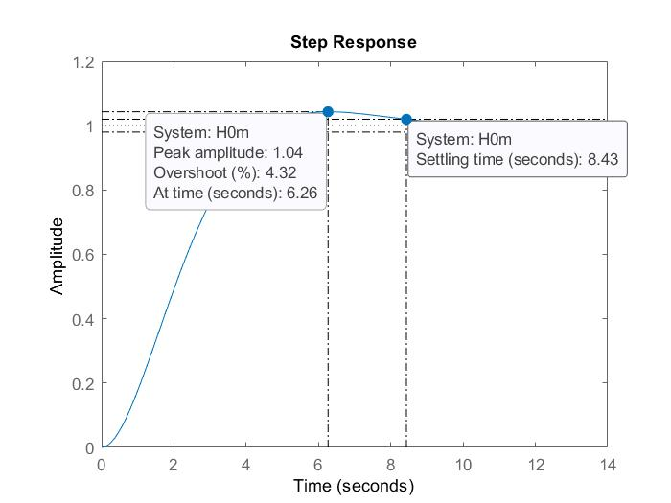

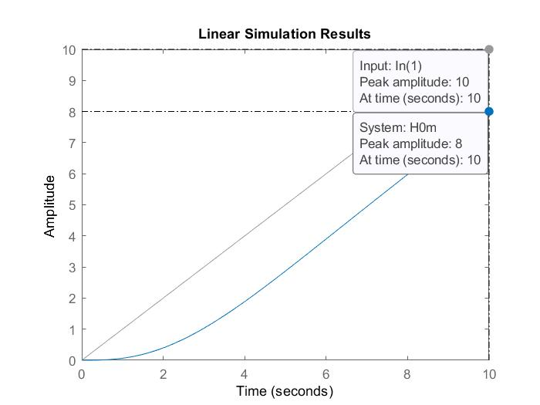

And for the symmetrical optimum closed loop system:

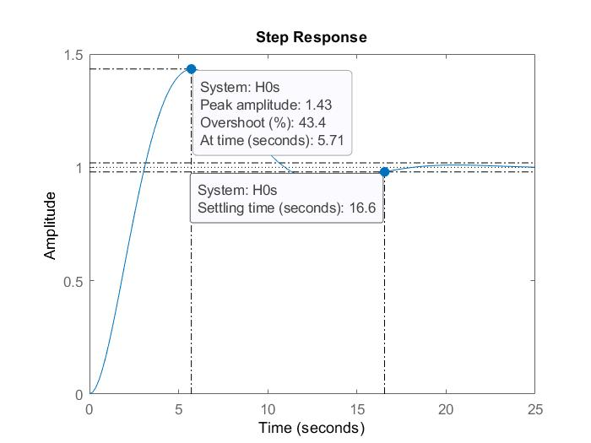

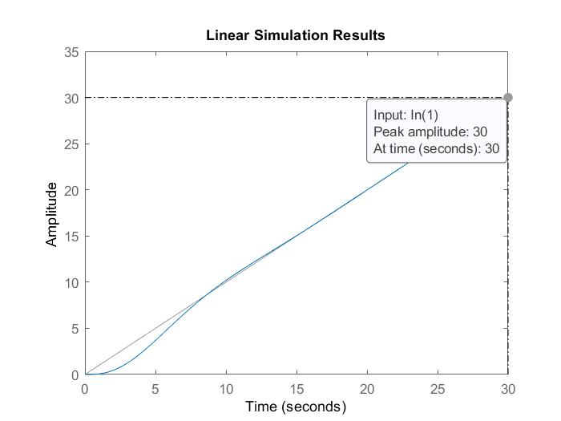

1. The step response for the magnitude optimum close loop system:



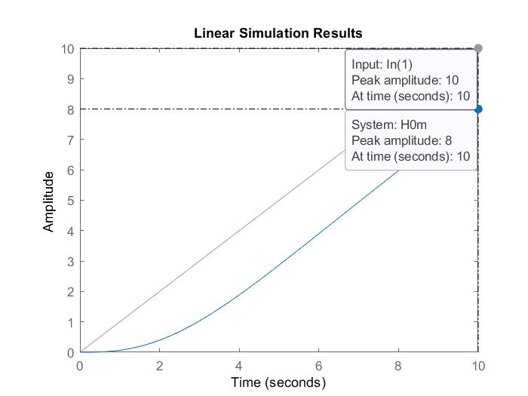

And for the symmetrical optimum closed loop system:





1. The step response for the magnitude optimum close loop system:





And for the symmetrical optimum closed loop system:





1. The step response for the magnitude optimum close loop system:

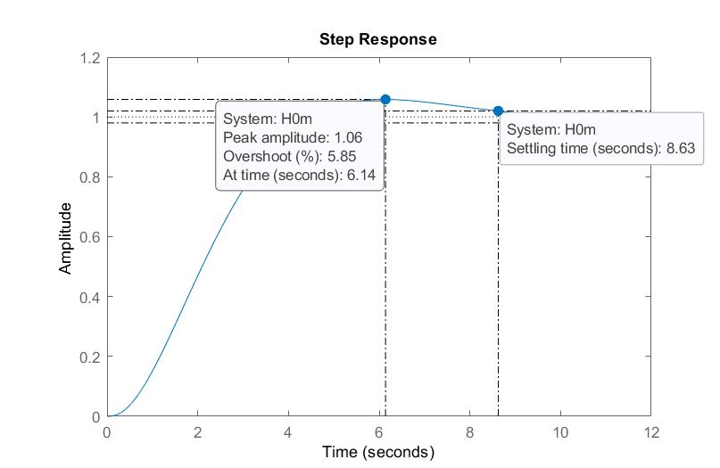

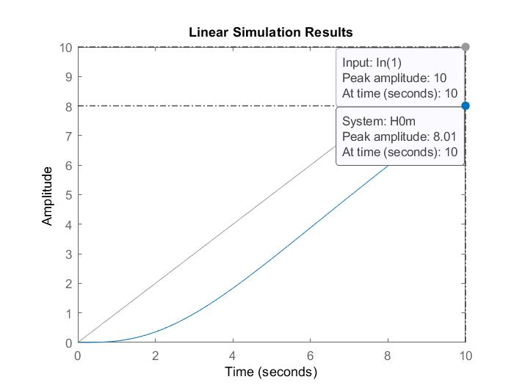

And for the symmetrical optimum closed loop system:

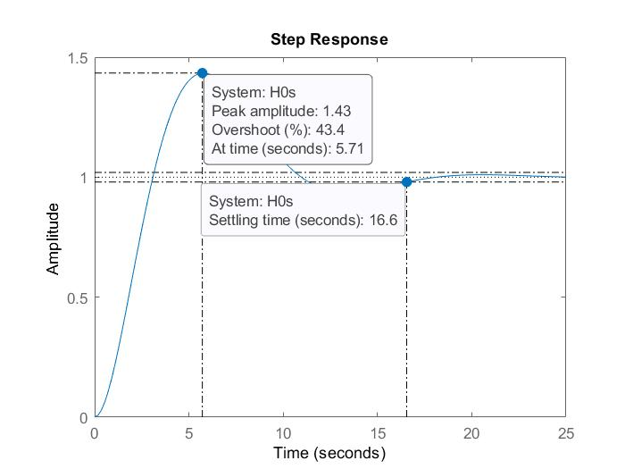



1. The step response for the magnitude optimum close loop system:



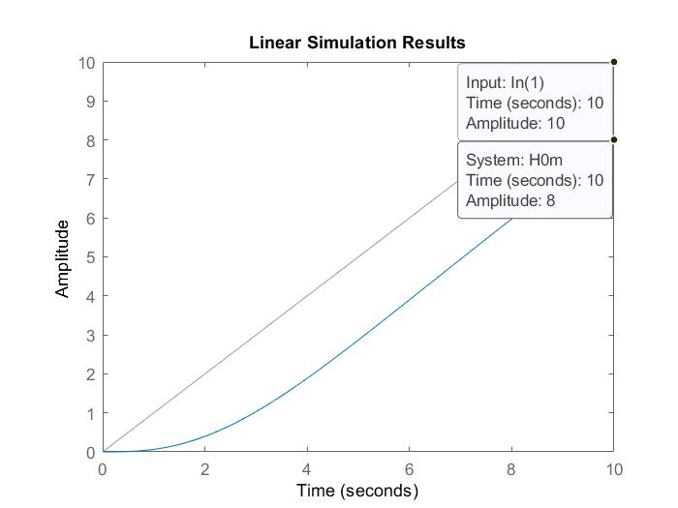

And for the symmetrical optimum closed loop system:



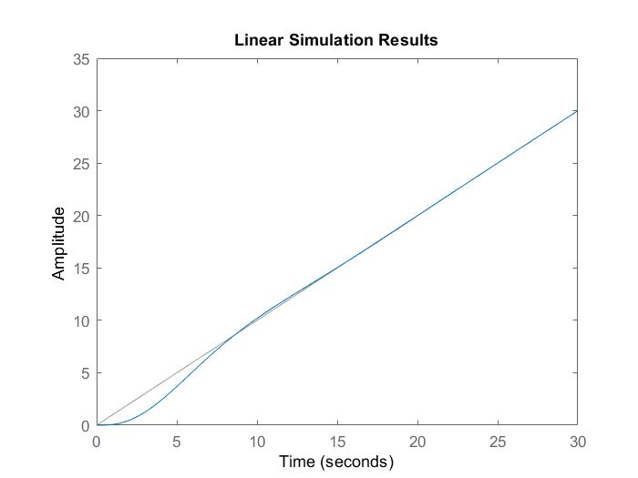

1. The step response for the magnitude optimum close loop system:





And for the symmetrical optimum closed loop system:

